Configuración actual de CubeMX: Firmware y periféricos

**Las siguientes configuraciones deben seguirse en orden.**

**No se debe modificar nada que no se diga en este archivo, por lo que si al realizar una configuración de las mencionadas aparecen más opciones, dejar como están por defecto las mismas.**

**RCC:**

- LSE: Crystal/Ceramic Resonator.

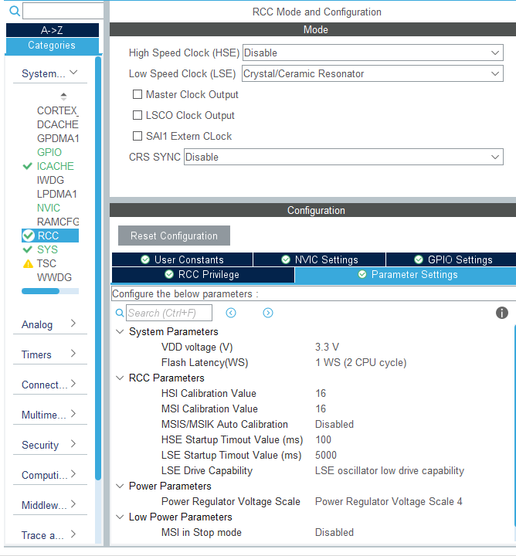

**SYS:**

- Timebase Src: TIM6

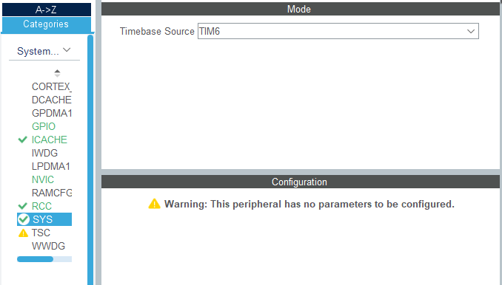

**ICACHE:**

- Mode: 1-way (direct mapped cache).

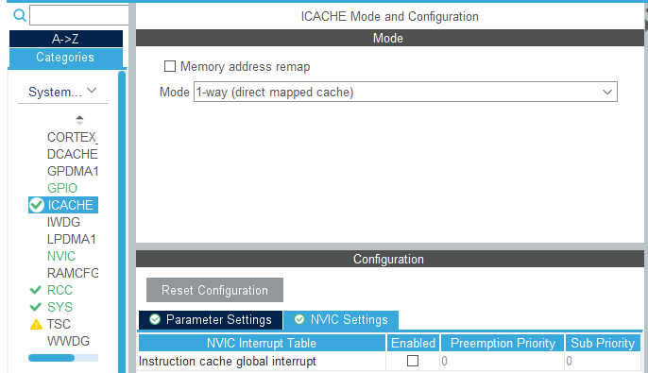

**ADC1:**

- IN1 🡪 IN1 Single-ended.

- IN2 🡪 IN2 Single-ended.

- IN3 🡪 IN3 Single-ended.

- IN4 🡪 IN4 Single-ended.

- Temperature Sensor Channel 🡪 ON.

- Vrefint Channel 🡪 ON.

- Clock Prescaler: Asynchronous clock mode divided by 2.

- Resolution: ADC 12-bit resolution

- Scan Conversion Mode -> Disabled

- Continous conversión mode -> Disabled

- Discontinuous Conversion Mode -> Disabled

- Enable Regular Conversions: Enable.

- Rank 1 🡪 Channel: Channel Temperature Sensor.

🡪 Sampling Time: 391.5 Cycles.

🡪 Offset Number: No offset.

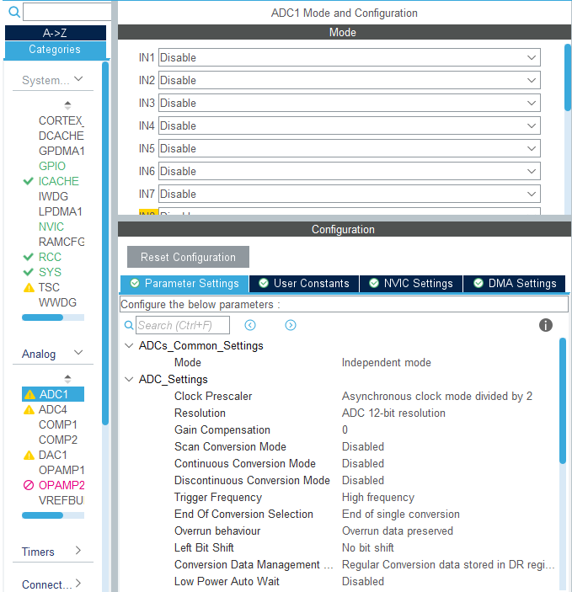

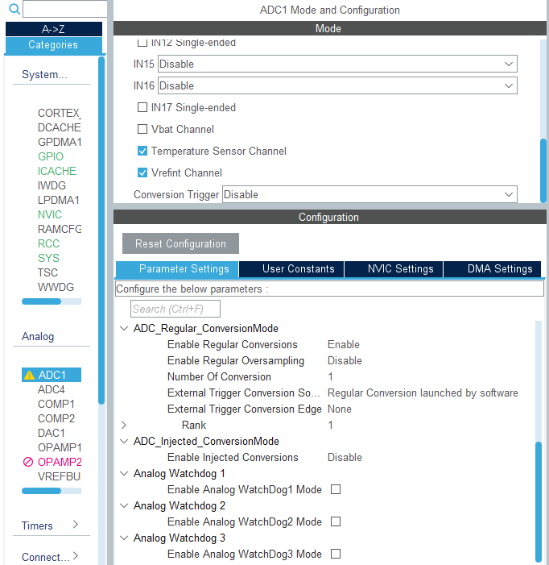

**LPTIM1:**

- Mode: Counts internal clock events.

- Clock 🡪 Clock Prescaler: Prescaler Div16.

- Counter 🡪 Period: 65635.

🡪 Repetition counter: 0.

- LPTIM1 global interrupt: Enabled.

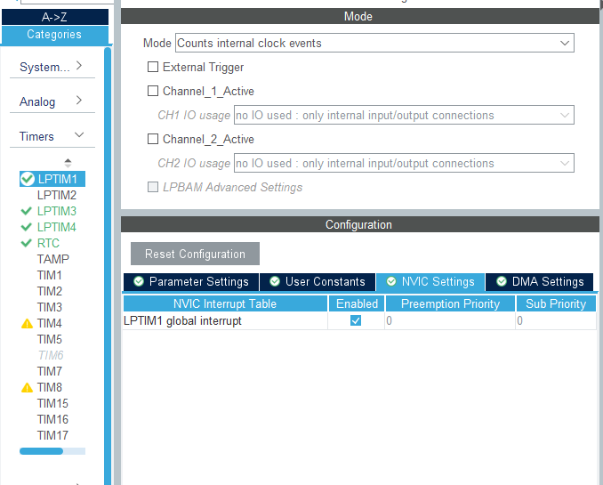

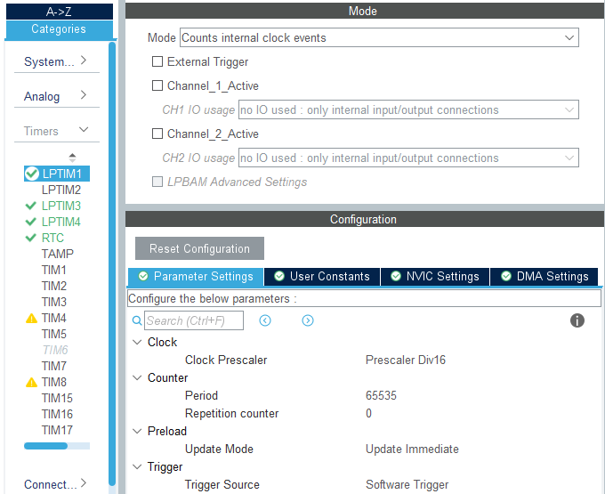

**LPTIM3:**

- Mode: Counts internal clock events.

- Clock 🡪 Clock Prescaler: Prescaler Div1.

- Counter 🡪 Period: 65635.

🡪 Repetition counter: 0.

- LPTIM3 global interrupt: Disabled.

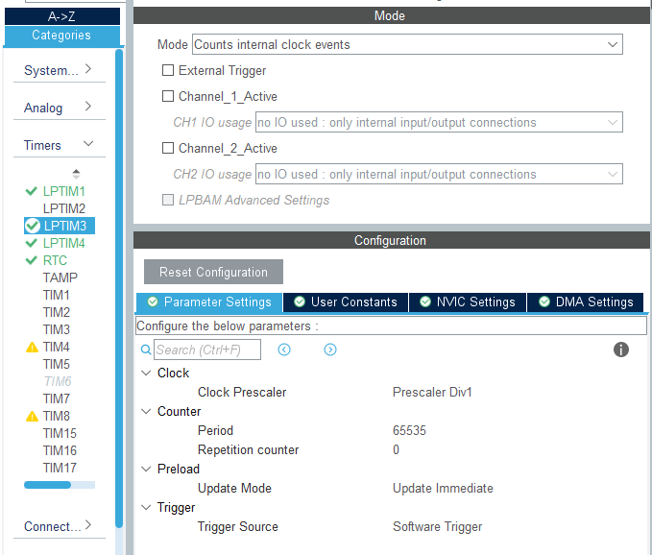

**LPTIM4:**

- Mode: Counts external Clock events with internal synchronization.

- Clock 🡪 ULP Clock Polarity: Rising Edge.

- Counter 🡪 Period: 65635.

🡪 Repetition counter: 0.

- LPTIM4 global interrupt: Disabled.

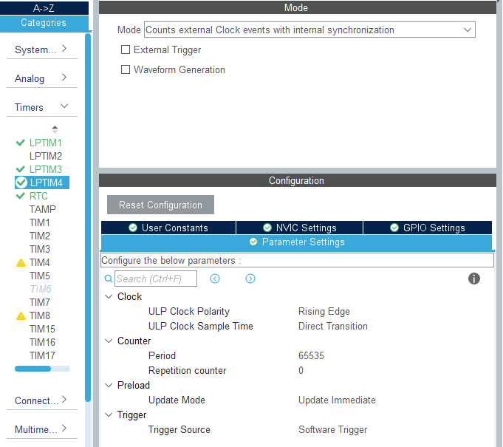

**RTC:** Descipcion

- Activate Clock Source: ON.

- Activate Calendar: ON.

- WakeUp: Internal WakeUp.

- Hour format: Hourformat 24.

- Data Format: Binary data format.

- Hours: Hora actual.

- Minutes: Minutos actuales.

- Seconds: Segundos actuales.

- Month: Mes actual.

- Date: Día actual (número).

- Year: Año actual.

- Wake Up Clock: RTCCLK/16.

- Wake Up Counter: 4096.

- NVIC Settings 🡪 RTC non-secure interrupt: Enabled.

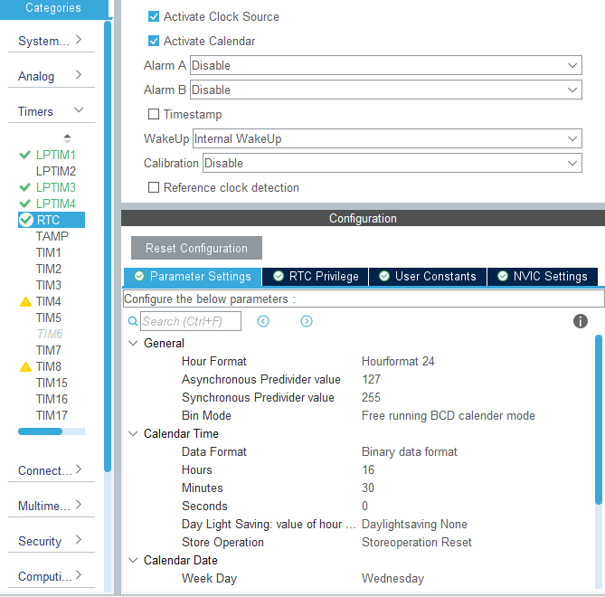

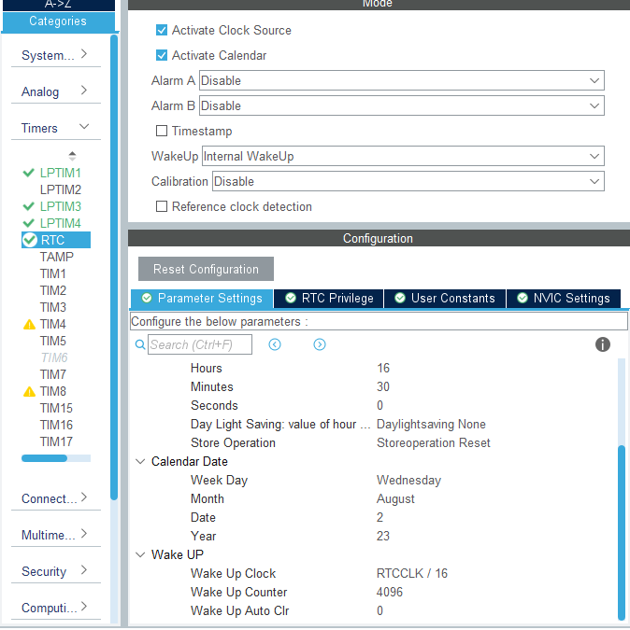

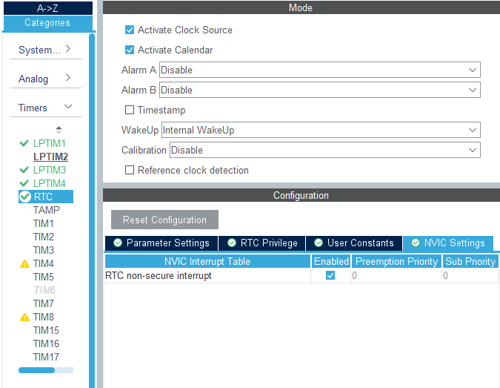

**SPI1:** Se conecta con el IC driver del LCD PCF8553. El microcontrolador solamente transmite datos. Se busco tasa de transferencia alta, para no estar mucho tiempo fuera de estados de bajo consumo.

- Mode: Half-Duplex Master.

- Data Size: 8 bits.

- Prescaler (for Baud Rate): 16.

- Baud Rate: 1.5 MBits/s.

- CRC Calculation: Disabled.

- NSSP Mode: Disabled.

- NSS Signal Type: Software.

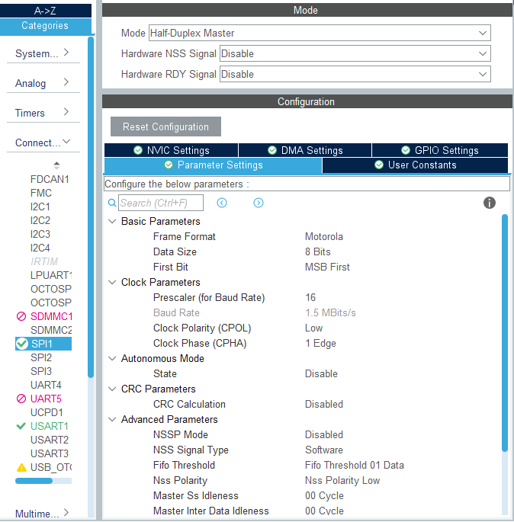

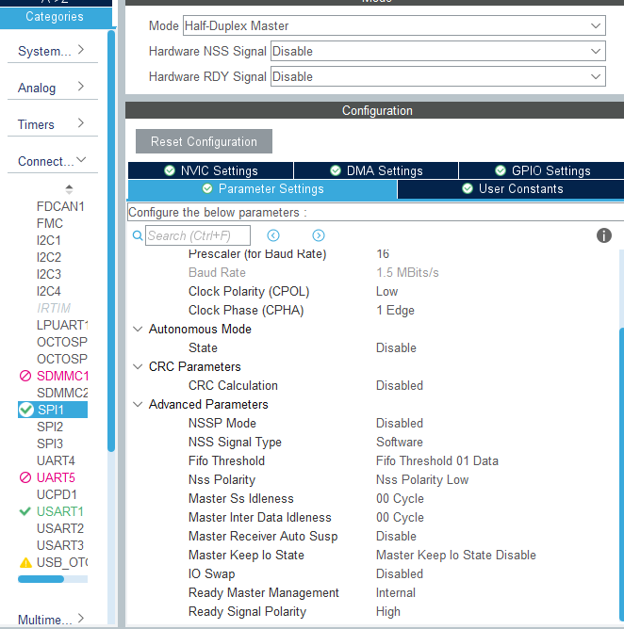

**USART1:** Se conecta al conector STLINK con propósitos de debuger.

- Mode: Asynchronous.

- Baud Rate: 115200 Bits/s.

- Word Length: 8Bits.

- Data Direction: Receive and Transmit.

**USART2:** sin implementar, pero se reserva los pines y se lo cablea a placa de usuario.

**USART3:** Se lo usa para conectar modulo IOT.

- Mode: Asynchronous.

- Baud Rate: 115200 Bits/s.

- Word Length: 8Bits.

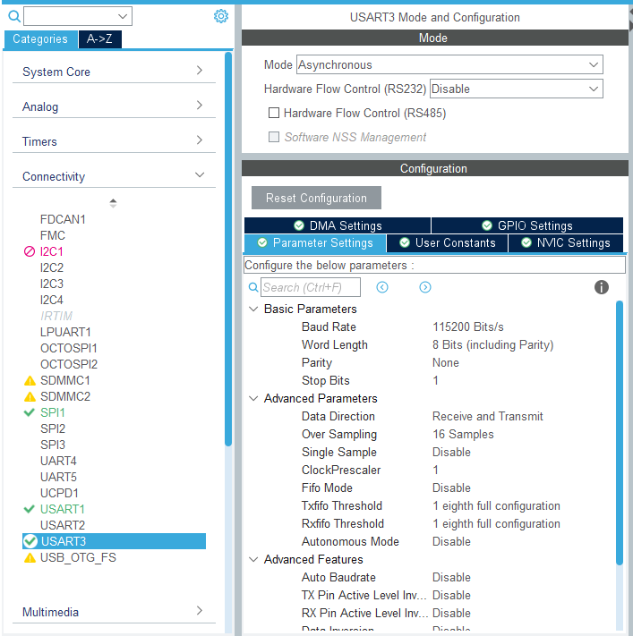

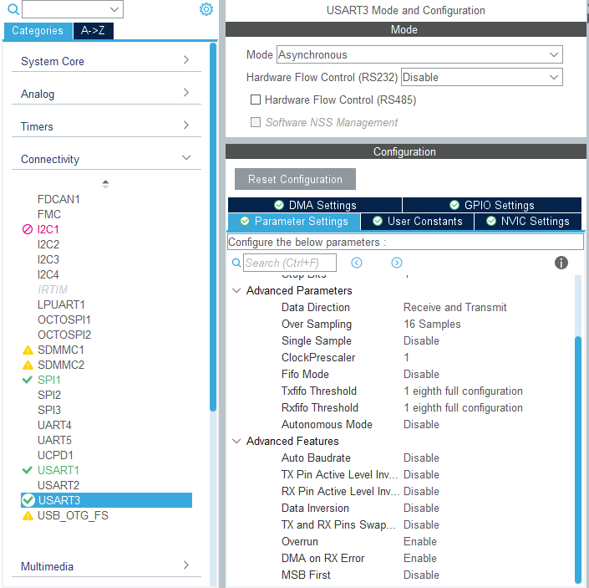

**PWR:**

- Low Power 🡪 Dead Battery Signals disabled: ON.

🡪 Power saving mode: ON.

- System power supply 🡪 Power Regulator: SMPS.

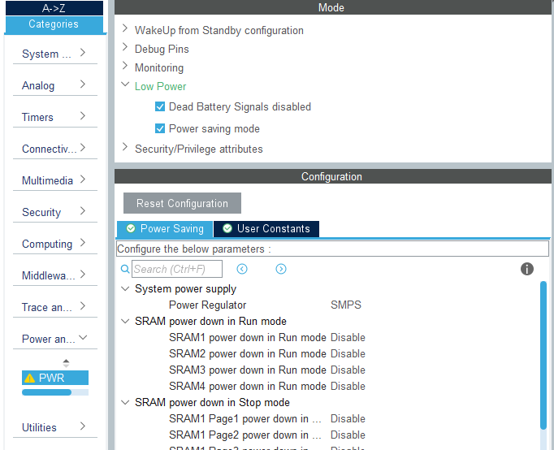

**Middleware and Software Packs 🡪 THREADX:**

- Core: ON.

- TraceX Support: ON.

- Low Power support: ON.

- Low Power 🡪 Enable LowPower Support: Enabled.

🡪 TX_LOW_POWER_TIMER_SETUP: app_threadx_lowpower_timer_setup.

🡪 TX_LOW_POWER_TICKLESS: Disabled.

🡪 TX_LOW_POWER_USER_ENTER: app_threadx_lowpower_enter.

🡪 TX_LOW_POWER_USER_EXIT: app_threadx_lowpower_exit.

🡪 TX_LOW_POWER_USER_TIMER_ADJUST: app_threadx_lowpower_timer_adjust.

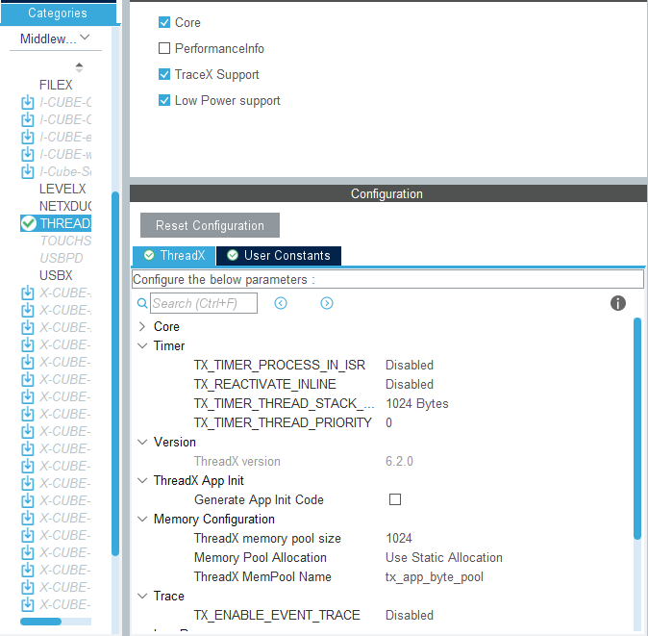

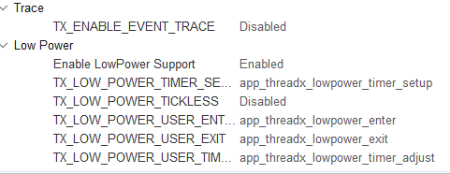

**Clock Configuration:**

- System Clock Mux 🡪 MSIS 🡪 SYSCLK: 24 MHz 🡪 AHB Prescaler: /1.

- ADC,DAC Clock Mux 🡪 SYSCLCK: 24 MHz.

- SPI1 Clock Mux 🡪 SYSCLCK: 24 MHz.

- USART1 Clock Mux 🡪 SYSCLK: 24MHz.

- RTC Clock Mux 🡪 LSE: 32.768 KHz.

- LPTIM3,4 Clock Mux 🡪 LSE: 0.032768 MHz.

- LPTIM1 Clock Mux 🡪 LSE: 0.032768 MHz.

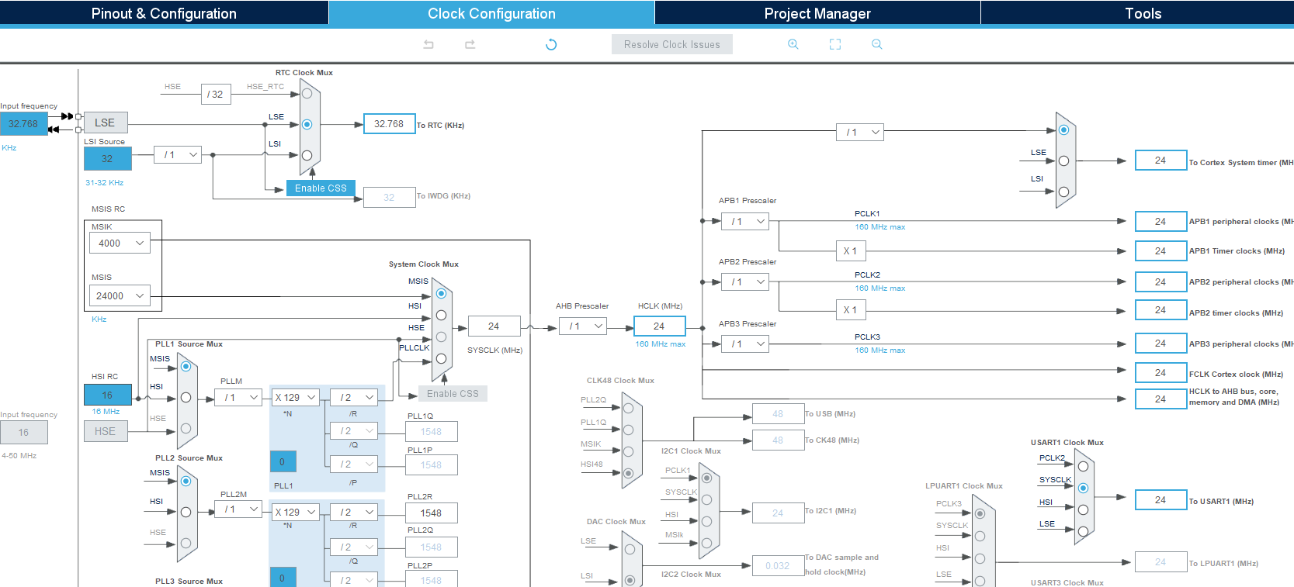

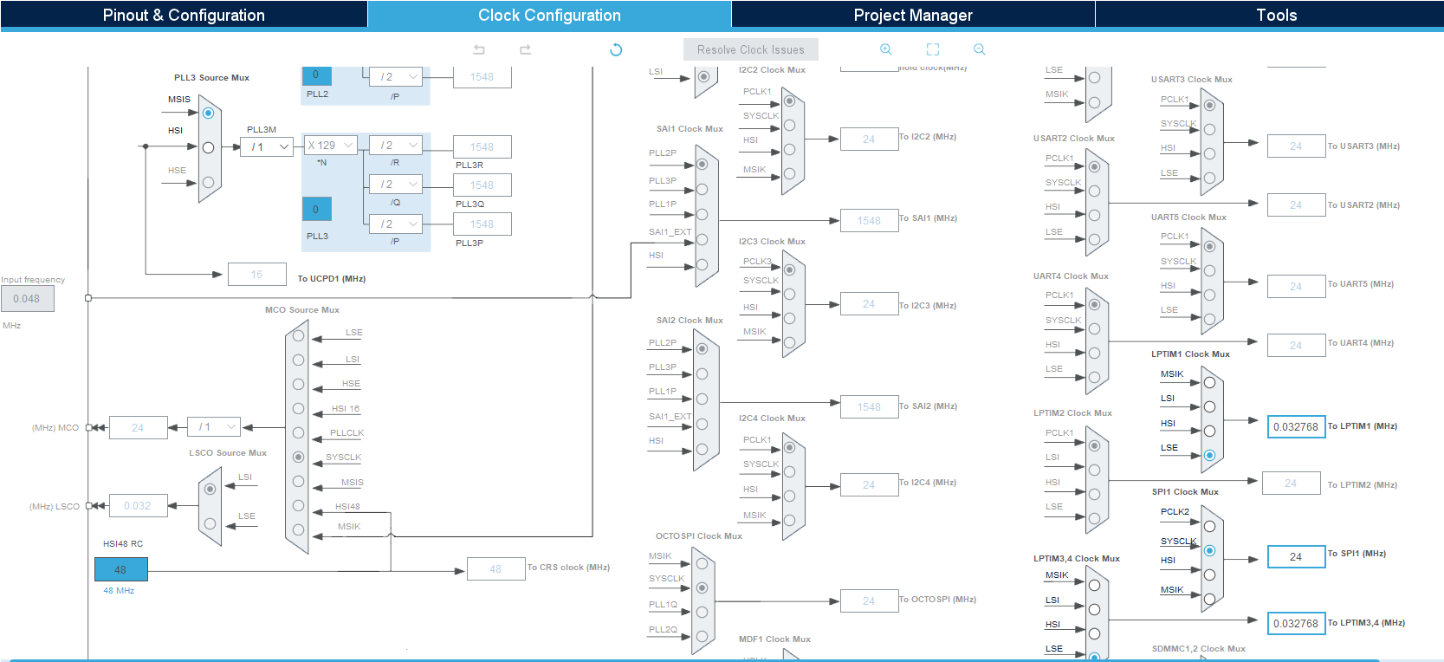

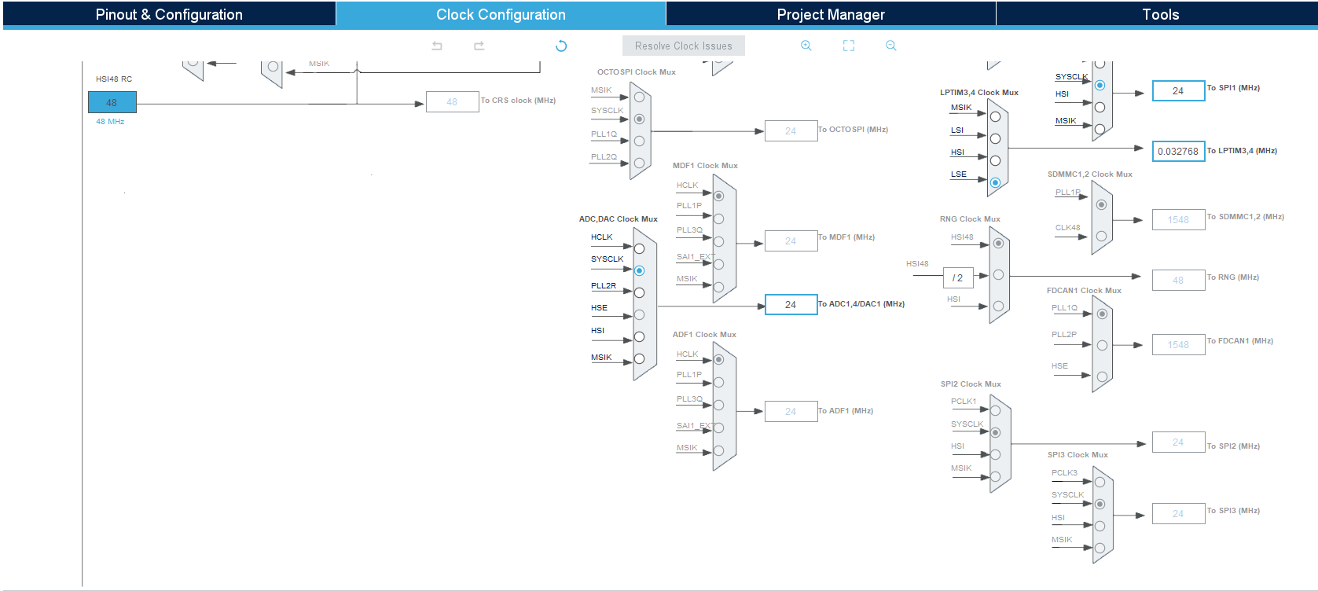

**Pinout view:**

Pines del micro no conectados sin configuración.

Pines conectador a un port undefined configurarlos como GPIO_Analog y label genérico, es decir nombre del puerto.

- PA1: SPI1_SCK 🡪 PCF8553_SCL

- PA4: GPIO_OUTPUT 🡪 PCF8553_CE

- PA6: GPIO_OUTPUT 🡪 PCF8553_RESET

- PA7: SPI1_MOSI 🡪 PCF8553_SDIO

- PA9: USART1_TX

- PA10: USART1_RX

- PA13: DEBUG_JTMS-SWDIO

- PA14: DEBUG_JTCK-SWCLK

- PB3: DEBUG_JTDO-SWO

- PB5: GPIO_OUTPUT 🡪 LED_ERROR_HANDLER

- PB6: GPIO_OUTPUT 🡪 LED_MCU_RUN

- PB7: GPIO_OUTPUT 🡪 LED_3

- PC0: ADC1_IN1 🡪 RTD_IN

- PC1: ADC1_IN2 🡪 BATTERY_LEVEL

- PC2: ADC1_IN3

- PC3: ADC1_IN4

- PC14: RCC_OSC32_IN

- PC15: RCC_OSC32_OUT

- PD8: USART3_TX

- PD9: USART3_RX

- PD13: LPTIM4_IN1 🡪 PULSE_IN

- PD14: GPIO_EXTI14 🡪 PULSE_IT

- PE10: GPIO_EXTI10 🡪 KEY_DOWN

- PE11: GPIO_EXTI11 🡪 KEY_UP

- PE12: GPIO_EXTI12 🡪 KEY_ENTER

- PE13: GPIO_EXTI13 🡪 KEY_ESC

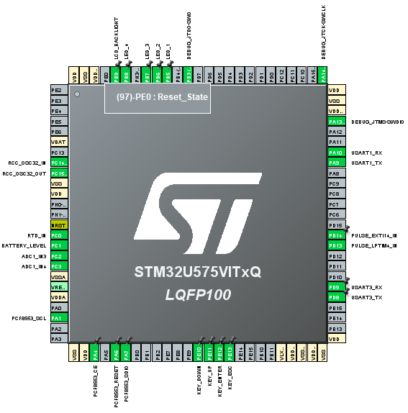

**NVIC:**

- EXTI Line10: Enabled 🡪 Preemption Priority: 5.

- EXTI Line11: Enabled 🡪 Preemption Priority: 5.

- EXTI Line12: Enabled 🡪 Preemption Priority: 5.

- EXTI Line13: Enabled 🡪 Preemption Priority: 5.

- EXTI Line14: Enabled 🡪 Preemption Priority: 5.

- LPTIM1 global interrupt: Enabled 🡪 Preemption Priority: 0.

- RTC non-secure interrupt: Enabled 🡪 Preemption Priority: 0.

